Come Visit KC – Project 2

Let’s use data to show residents and travelers alike all the reasons they should explore Kansas City. Our project will include visualizations of weather trends, attractions, restaurants, hotels, public transportation routes, housing market values, and crime rates.

Specific datasets and links to them

<http://www.city-data.com/city/Kansas-City-Missouri.html>

<http://www.marc.org/Data-Economy>

<https://data.kcmo.org/>

<https://data.kcmo.org/Transportation/KCATA-Bus-Stops/bd2s-bfst>

<https://www.brewerydb.com/>

Screenshots of 3-4 “inspiring” visualizations

Scatterplot

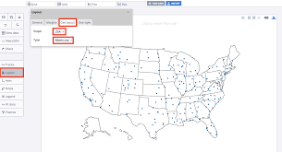

Heat Chart

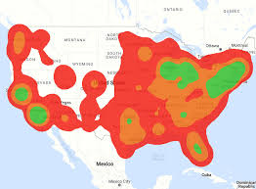

Current Conditions

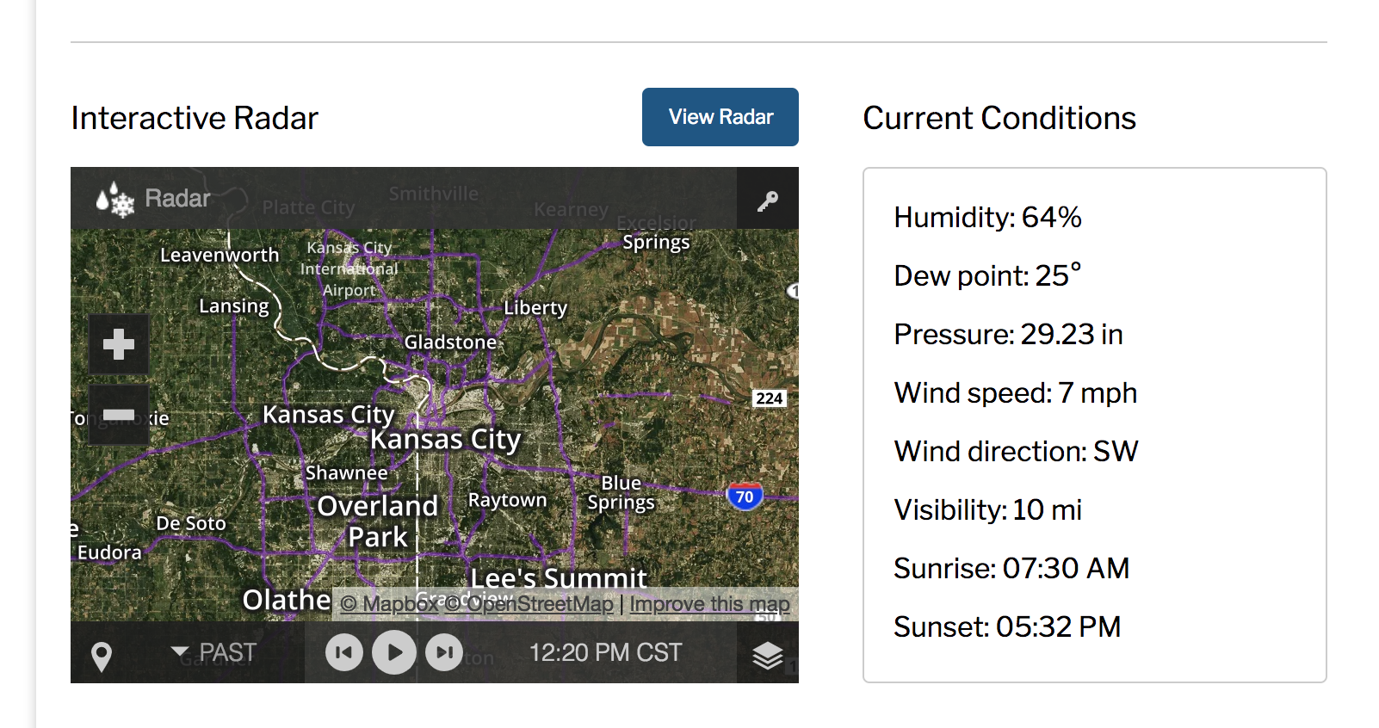

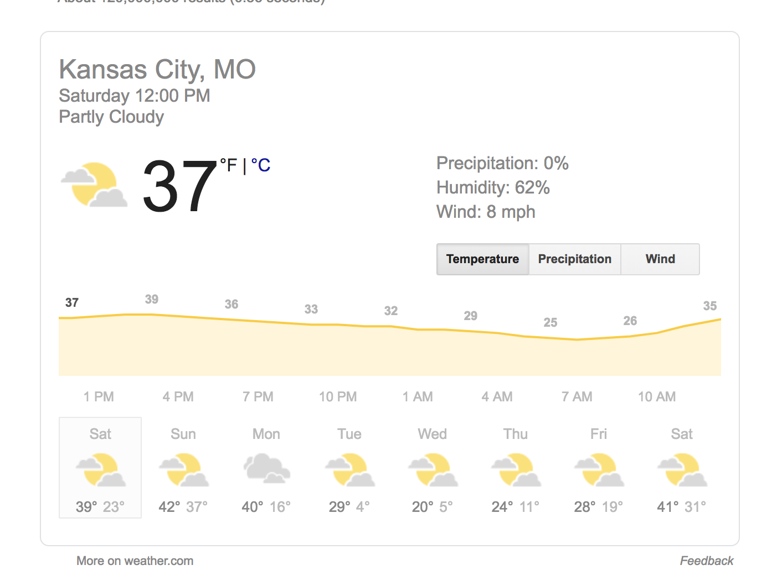

Sketch of final design

We are using this website as inspiration for our final design:

<https://www.st-christophers.co.uk/travel-tips/blogs/2017/the-ultimate-interactive-tourist-map-of-paris>

Here is a screen shot: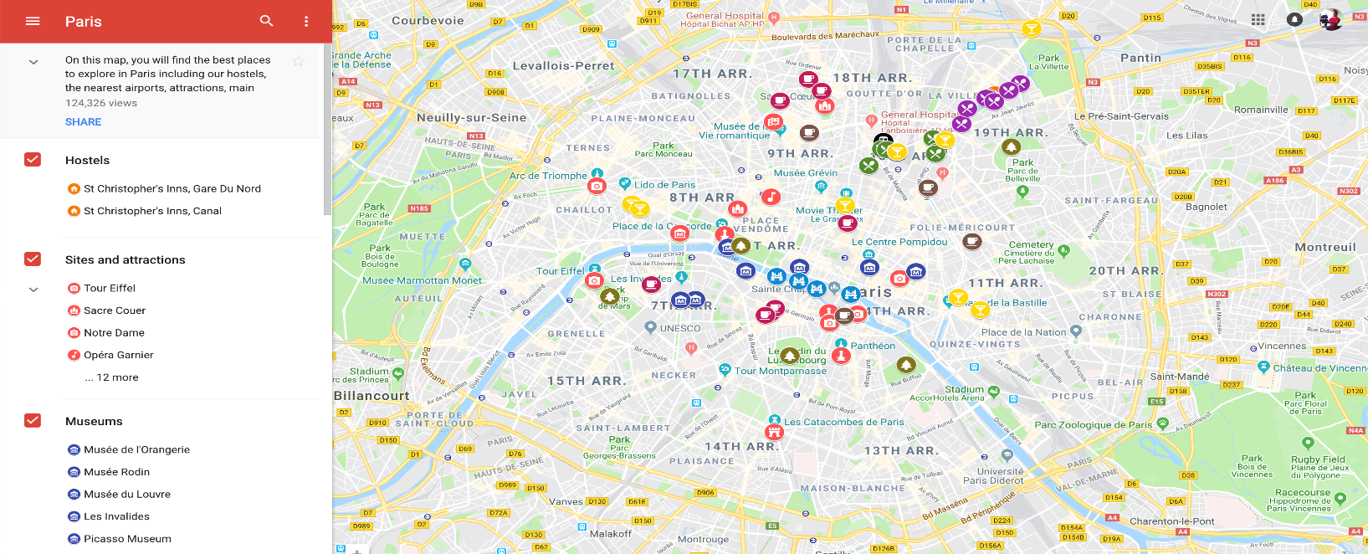

Link to primary GitHub repository

https://github.com/TrueBlue8515/Project_2.git

**Possible Data to include in presentation**:

Weather

attractions

restaurants

nearby hotels/highest rated

Transportation routes

Crime hot spots

Market value

Shopping

Breweries

Night/Day Map